Advanced Reporting
A study guide to the system you built
From messy platform exports to an honest, interactive reporting product —
ingestion, the durable store, the naming decoder, the MMM, the dashboard, and what's next.
July 2026 · matches the codebase at commit 4b714af

Contents
Contents 2
1. What this project is 3
2. The journey of a number 3
3. The three attribution systems 4
4. The dashboard system 5
5. The media mix model 7
6. The planner and the naming loop 7
7. The engineering spine 8
8. What's next — the agent system 8
9. Glossary 9

1. What this project is
Advanced Reporting is an end-to-end reporting product for advertising campaigns. It takes the messy CSV exports every ad platform produces, turns them into one clean, durable, honestly-labeled dataset, and presents that data three ways: an interactive dashboard with an editorial narrative, media mix modeling that estimates what actually drives outcomes, and a campaign planner that turns those estimates into budget allocations and correctly-named campaigns.
Two convictions shape every design decision, and understanding them makes the rest of the codebase predictable:
- The data work is the product. Charts are cheap; a store that survives platform data deletion, refuses to double-count, and never mixes attribution systems is what clients actually pay for.
- Honesty is a feature, not a caveat. Platforms over-claim their own conversions; models are uncertain; some ad names can't be decoded. This tool says so — visibly, structurally, every time — instead of hiding it.

2. The journey of a number
The best way to understand the architecture is to follow one number — say, a week of Meta spend — from a downloaded export to a dashboard tile.
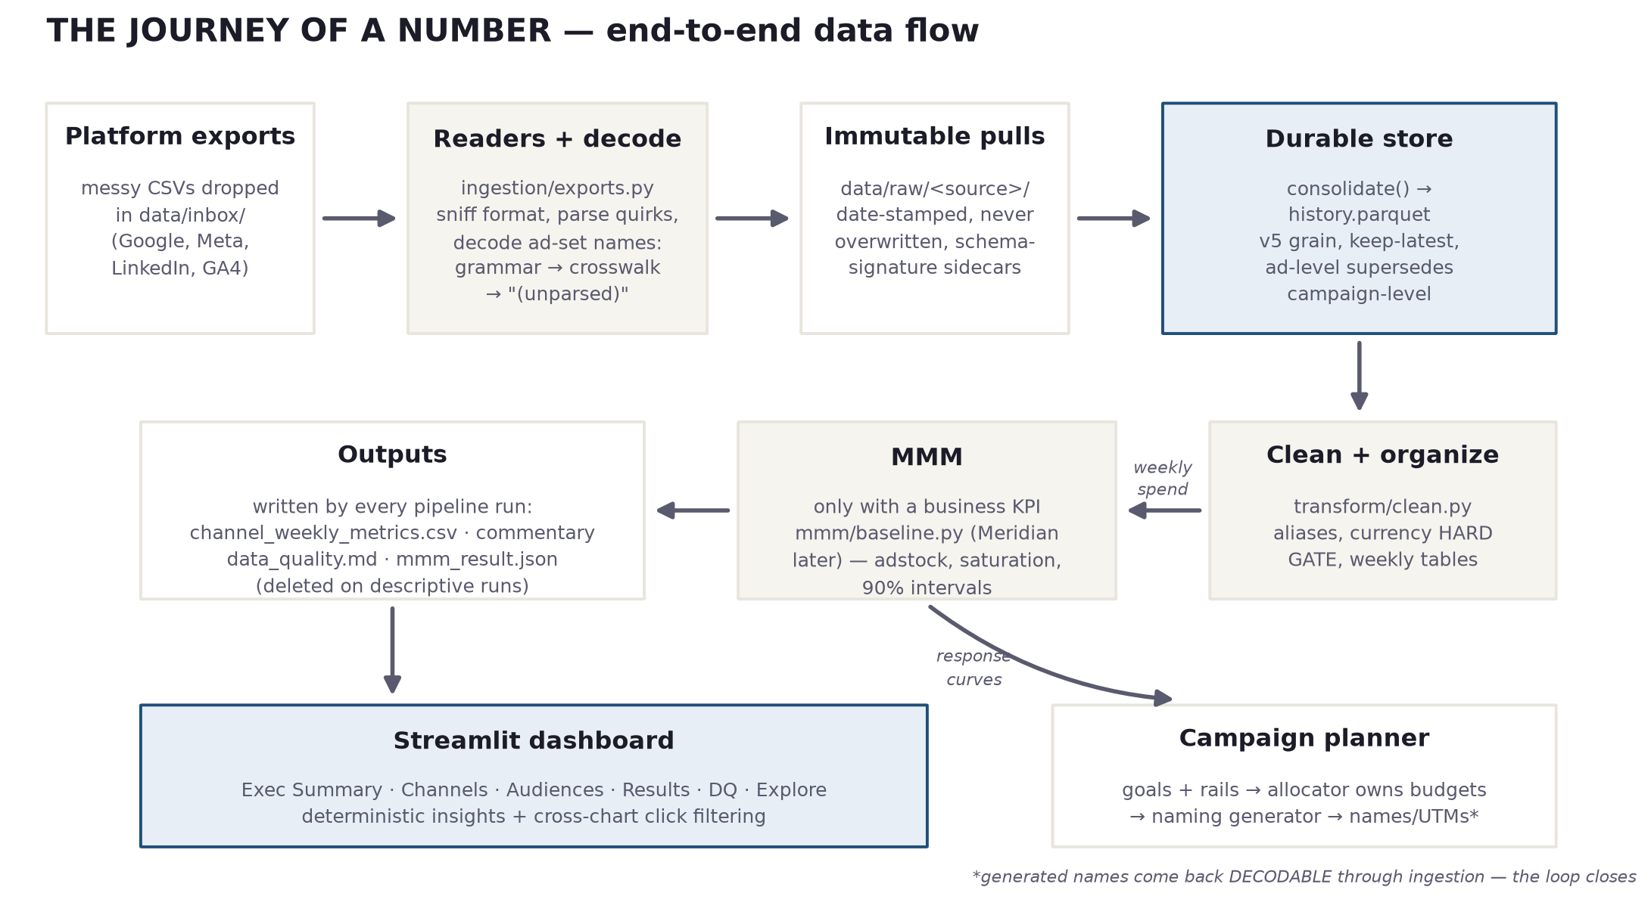
Figure 1 — the end-to-end pipeline. Two entry points (file drop, synthetic source), one durable store, everything downstream reads from it.
Drop. A marketer downloads an ad-set report from Meta Ads Manager and drops it in data/inbox/. Nothing about the file is standardized — verbose headers, currency hidden in a column name, ad-set names in whatever convention (or none) the account uses.
Read and decode. ingestion/exports.py sniffs which platform and grain the file is, survives its quirks (title rows, quoted thousands separators, locale dates, preamble metadata), and maps it onto the canonical schema — one row per date × channel × campaign × ad-group × geo. As it reads, the naming decoder parses each ad-set name back into audience and creative fields: grammar first, then the curated crosswalk for known non-conforming names, then an explicit "(unparsed)" bucket. Never a guess.
Store immutably. The parsed rows are written as a date-stamped pull under data/raw/ that is never overwritten, with a sidecar recording the schema version. Then consolidate() merges every pull into history.parquet — deduplicating on the grain, keeping the latest restatement, and applying the supersede rule: if ad-level rows and their campaign-level aggregate both exist, the finer grain wins, so ingesting both report types can never double-count spend.
Clean and organize. transform/clean.py standardizes channel labels, refuses to sum mixed currencies (a hard error, not a warning), fills calendar gaps, and produces the weekly tables everything downstream reads — plus a data-quality report that says exactly what was fixed.
Model — when honesty allows. If a weekly business-KPI series exists (CRM matchback), the MMM runs and estimates each channel's contribution with uncertainty intervals. If not, the pipeline runs in descriptive mode: everything works, nothing pretends to know incrementality, and any previous model's artifacts are deleted so a stale model can never render over new data.
Present. The dashboard reads the weekly tables and store, computes every insight deterministically, and renders the story. The planner closes the loop: model estimates feed budget allocation, which feeds the naming generator, whose names come back decodable when the next export lands.
CHECK YOURSELF
• A client drops both a campaign-level and an ad-set-level Meta export in the inbox. Why doesn't spend double?
• What has to exist before the MMM is allowed to run, and what happens to old model artifacts when it can't?
• Where does an ad-set name like RETARGET_SITE-90D_FEED get turned into audience fields — and what happens to Advantage+ broad (test)?

3. The three attribution systems
The single most important idea in the product: there are three different systems that all call something a "conversion", and they must never be summed or swapped.
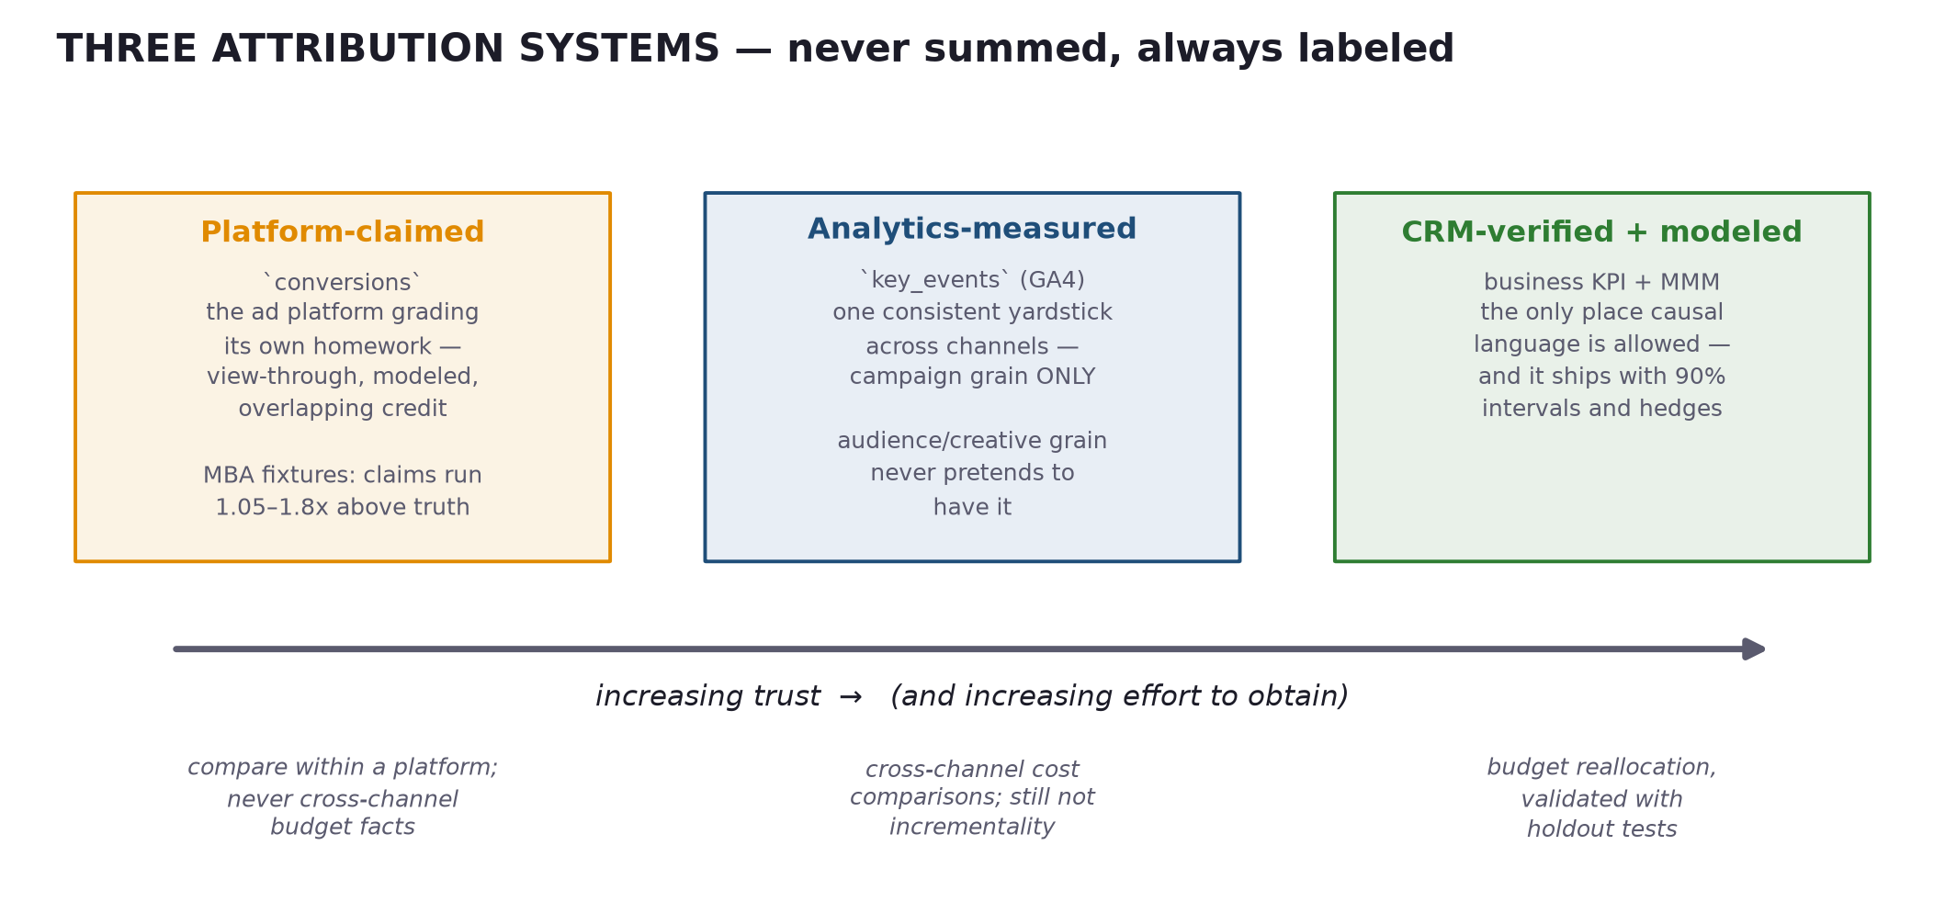
Figure 2 — the trust gradient. Each number on every page is labeled with which system produced it.
This is enforced structurally, not editorially. The schema keeps platform-claimed conversions and GA4 key_events in separate columns that no aggregation ever adds together. The audience/creative tables do not have a key-events column at all — GA4 measures at campaign grain, so finer grains only ever show claimed numbers, labeled as such. And causal verbs are reserved for the MMM, which pays for them with 90% intervals.
The claim ratio (claimed ÷ measured, about 1.6x on the MBA fixtures) became the dashboard's signature visual precisely because most reporting tools hide it. Showing it builds the trust that makes the rest of the report credible.
CHECK YOURSELF
• Why does the audience table structurally lack a key-events column rather than just leaving it blank?
• The platforms claim 1,302 conversions and GA4 measures 839. What are the legitimate uses of each number?
• When is the word "drove" allowed in commentary, and what must accompany it?

4. The dashboard system
The dashboard is a Streamlit multipage app with a strict separation: pure, tested pandas logic below; thin Streamlit layout above. Pages never compute — they arrange.
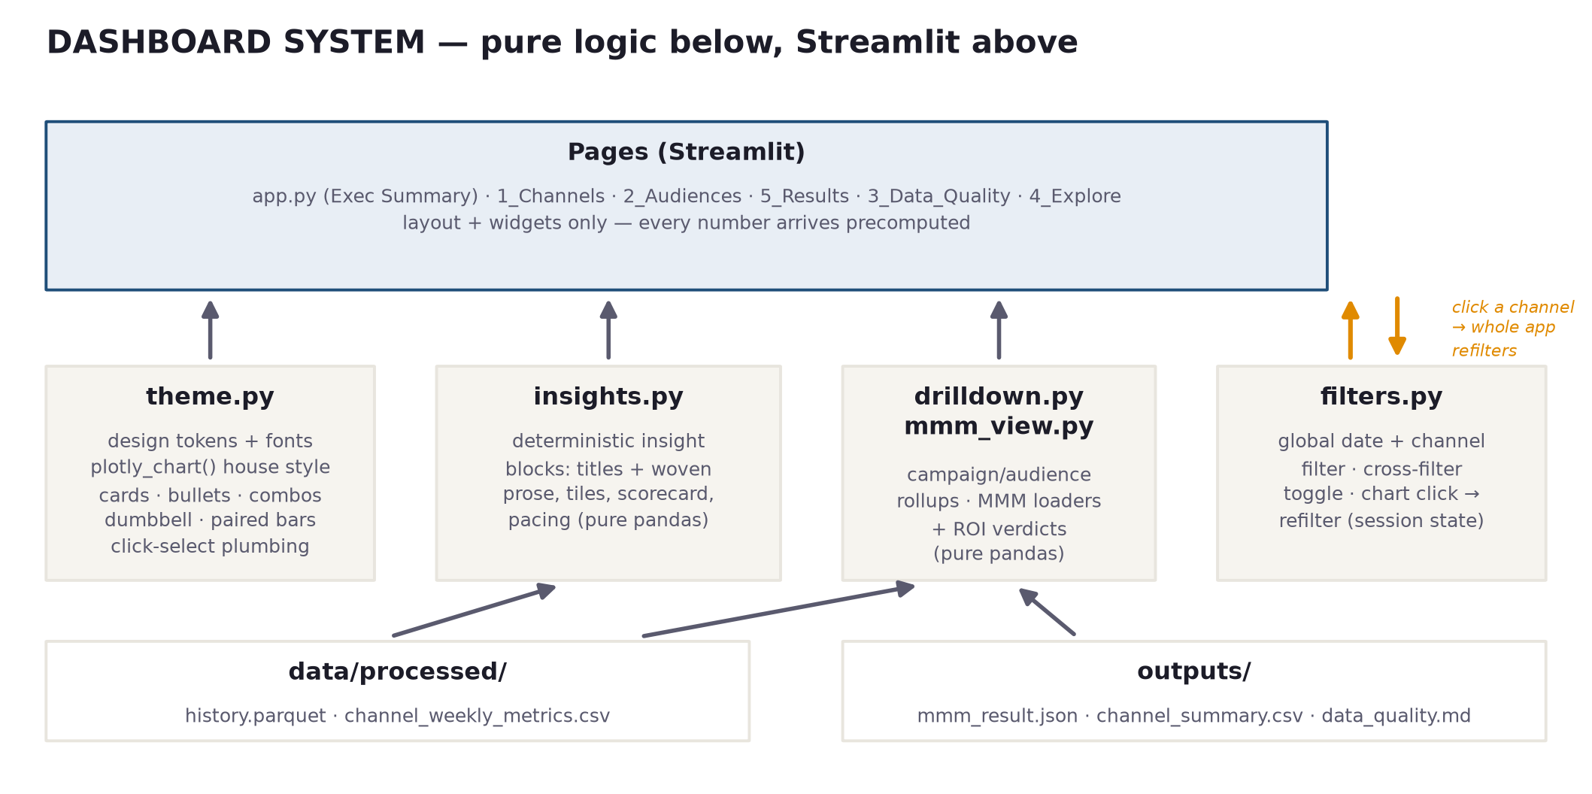
Figure 3 — module map. The four pure modules are unit-tested without any UI running.
- theme.py — the design system: tokens (ink/paper/accent, the amber-claimed vs blue-measured honesty pair, channel colors), Fraunces + Source Sans typography, and the one plotly_chart() helper every chart must pass through. Chart titles live outside figures as serif action titles — an insight sentence, never a label.
- insights.py — the deterministic narrative: KPI trend, claims-vs-measured, cost-per-outcome, pacing, tier scorecard, headline tiles. Each returns computed facts plus template prose; if the data can't support a block, the block doesn't render.
- drilldown.py / mmm_view.py — rollups for Channels/Audiences and loaders for the Results page (including the profitable / unproven / unprofitable ROI verdicts).
- filters.py — the global date + channel filter, and the cross-filter: click a channel in any chart and the whole app refilters to it; click again (or the chip) to clear. This is the Power BI-style interactivity, done with Streamlit's selection events and a pending-state trick (a widget's session value can't be written after it renders, so clicks stage the change and rerun).
Page map: Exec Summary (tile row, lede, tier gauges, quick views, narrative blocks), Channels (spend/CPM combo, efficiency paired-bars, campaign table, nested campaign → audience → creative breakdown), Audiences (cost rankings, spend-vs-claimed dumbbell, unparsed callout), Results (the MMM page — appears only when a model matches the current data), Data Quality (store provenance + the pipeline's DQ report), Explore (KPI pyramid, funnel, free-text lens).
CHECK YOURSELF
• Why do chart titles live outside the Plotly figure, and what makes a valid title on the narrative page?
• Walk through what happens, step by step, between clicking the Meta bar and every chart refiltering.
• Why is the fact that insights.py is import-free of Streamlit worth protecting?

5. The media mix model
The MMM answers the question platform attribution can't: what actually moved the business KPI? The baseline engine is deliberately transparent — every step is inspectable, which is what makes its claims defensible:
- Adstock carries each week's spend into following weeks with a fitted decay — advertising doesn't stop working at midnight.
- Hill saturation bends the response curve flat as spend grows — the tenth dollar buys less than the first.
- Ridge regression with a spend-scaled penalty fits transformed spend to the KPI, shrinking correlated channels toward a common ROI rather than toward zero — so channels that move together share credit instead of one stealing it.
- Bootstrap intervals — the model refits on resampled data to produce the 90% bands on every contribution and ROI. The intervals are the honest read; the points are just the middle of them.
Quality is enforced, not asserted: CI runs the whole pipeline on synthetic data with known ground truth, and the recovery gate fails the build unless per-channel ROI is recovered within 2x and channel ranking is right (currently: 5/5 channels, rank correlation 0.90, holdout R² ≈ 0.74).
Basic vs advanced: everything renders from the persisted MMMResult contract, so the target engine — Google Meridian, Bayesian, with proper priors and geo-level modeling — will drop in behind the same interface and the same Results page. Its mapping stays deliberately guarded (it raises) until it's validated against the recovery gate like everything else.
CHECK YOURSELF
• Why shrink correlated channels toward a common ROI instead of toward zero?
• What exactly does the recovery gate test, and why does it only run on synthetic data?
• A channel's ROI interval is 0.4–1.6x. What may the report say about it — and what may it not?

6. The planner and the naming loop
The planner inverts the reporting direction: given goals and rails (committed hard constraints — allowed platforms, audience library, budget rules), it produces a validated campaign plan. Its architecture previewed the agent system: an optional LLM may select and justify audiences and creatives, but only from the rails' vocabulary, and the deterministic allocator owns every budget number, water-filling spend against the MMM's response curves.
The plan feeds the naming generator, which builds campaign/ad-set/ad names from a fixed grammar — and because the grammar is fixed, the decoder in the ingestion layer can parse those names back into audience and creative fields when the performance exports come home. Encode on the way out, decode on the way in: the loop is why audience-level reporting exists at all, and the unparsed rate is the sales pitch for adopting the convention.

7. The engineering spine
- Tests: 208 and counting, spanning schema round-trips, the store's grain rules, reader quirks, insight prose, chart styling, and the MMM's math. Every pure module is tested without the UI.
- CI (GitHub Actions): lock-file sync → lint (ruff) → synthetic data → ingest → full pipeline incl. the recovery gate → tests. A red run means something real broke — including model quality.
- Two machines, one repo: GitHub is the bridge; pull when you sit down, push when you stand up. Home runs uv with the lockfile; work runs plain venv + pip (winget is blocked there), which is the first suspect if tests ever disagree between machines.
- Secrets and data never enter git: .env, config/config.yaml, data/, outputs/, and system/context/ are all gitignored. Everything demo-able regenerates deterministically from seeded scripts.

8. What's next — the agent system
The next build (brief: AGENT_SYSTEM_BRIEF.md) adds light agentic capabilities under one law, inherited from the planner: agents configure, the deterministic engine computes, agents narrate over computed facts.
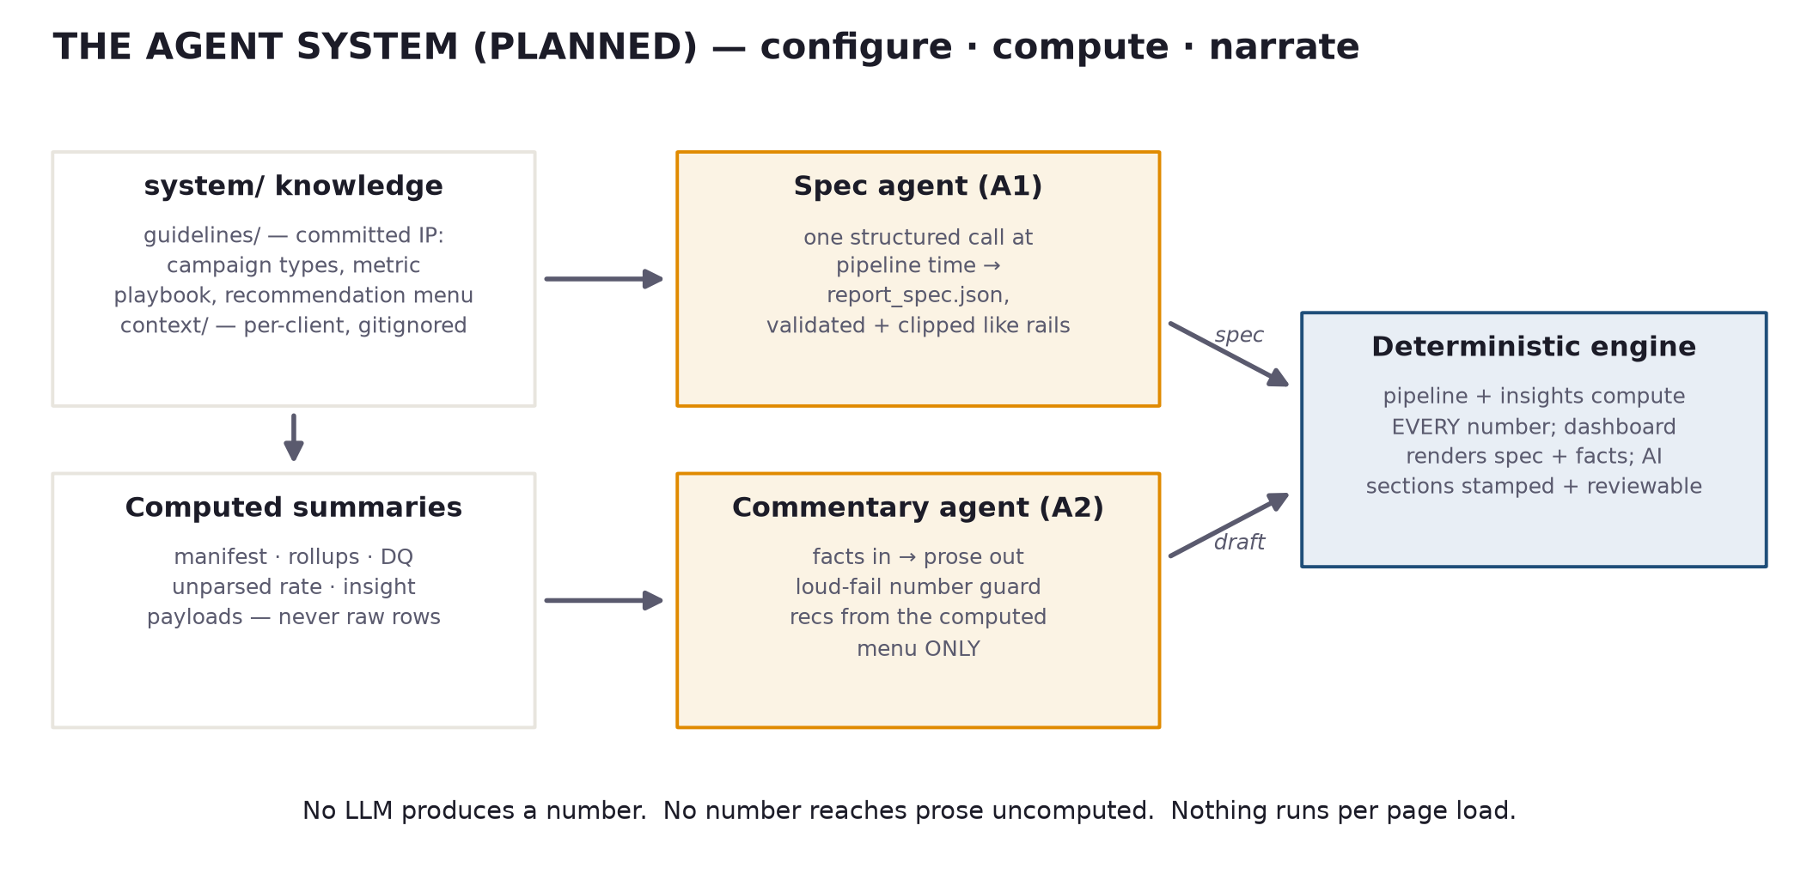
Figure 4 — the planned agent system. Knowledge in system/ (guidelines committed, client context gitignored); agents run at pipeline time only.
Phase A1, the spec agent, reads your guidelines plus computed data summaries and emits a validated report spec — so the dashboard arranges itself for a new client's campaign type with zero hand-configuration. Phase A2, the commentary agent, drafts prose and recommendations from computed facts, policed by a loud-fail number guard (any numeral not present in the input facts rejects the artifact) and a recommendation menu it cannot step outside. Your job before the build: fill in the system/guidelines/ skeletons — that domain knowledge is what makes the output yours.

9. Glossary
Term | What it means here
Adstock | The carryover of advertising: this week's ads keep working in later weeks, decaying geometrically. The MMM transforms spend with adstock before fitting.
Saturation (Hill curve) | Diminishing returns: the response to spend flattens as spend grows. The response curves on the Results page are these fitted curves.
MMM (media mix model) | A statistical model decomposing a business KPI into baseline + per-channel contributions using weekly spend. Correlational, interval-bound — not proof.
Baseline (model) | What the KPI would do with no paid media — seasonality, organic demand, controls. The waterfall's first bar.
Ridge regression | Linear regression with a penalty that shrinks coefficients, keeping correlated channels from stealing each other's credit. Ours shrinks toward a common ROI, not zero.
Bootstrap CI | Uncertainty intervals made by refitting on resampled data many times. The 90% intervals on ROI come from this.
Recovery gate | CI test on synthetic data with KNOWN truth: the model must recover per-channel ROI within 2x and rank channels correctly, or the pipeline fails.
Platform-claimed | Conversions per the ad platform's own attribution. Directional at best; over-claims by design (view-through, modeled, overlapping credit).
Key events (GA4) | Analytics-measured conversions — one consistent yardstick across channels, campaign grain only. Still not incrementality.
Claim ratio | Platform-claimed conversions ÷ analytics-measured key events. The signature honesty visual; ~1.6x on the MBA fixture data.
Grain | The columns that uniquely identify a row. Store grain (v5): date, channel, campaign, ids, ad_group, geo, source.
Supersede | Store rule: when ad-level rows and their campaign-level aggregate both arrive, keep the finer grain and drop the aggregate — mixed drops can't double count.
Naming decode / crosswalk | Ad-set/ad names built by the naming generator parse back into audience/creative fields. Non-conforming names get a curated crosswalk mapping or land in "(unparsed)" — never guessed.
ROAS vs ROI | ROAS = platform revenue ÷ spend (self-attributed). ROI here = modeled incremental return from the MMM, with intervals. Different systems; never mix.
Rails | Committed hard constraints (planner_rails.yaml) that clip anything an LLM proposes. The agent system generalizes this idea.
Descriptive mode | Pipeline without a business KPI: dashboard + honest commentary, no MMM. Deletes any previous model's artifacts so stale results can't render.
Generated 11 July 2026 from the live codebase. Companion docs in the repo: CLAUDE.md (conventions), DASHBOARD_REDESIGN_BRIEF.md, AGENT_SYSTEM_BRIEF.md, PRODUCTION docs to come.

